Enter your **Email** and **Password** to access the Bigeye dashboard. If you are new to Bigeye, you may have to sign up first.

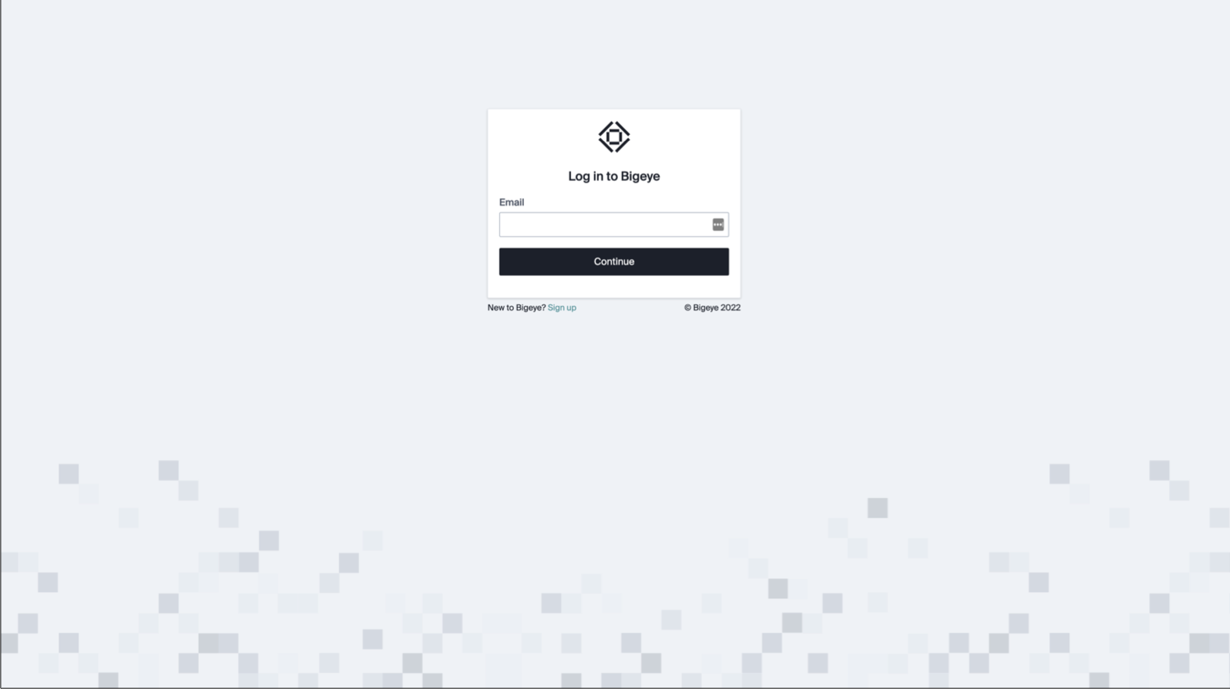

Okay, so here we are.

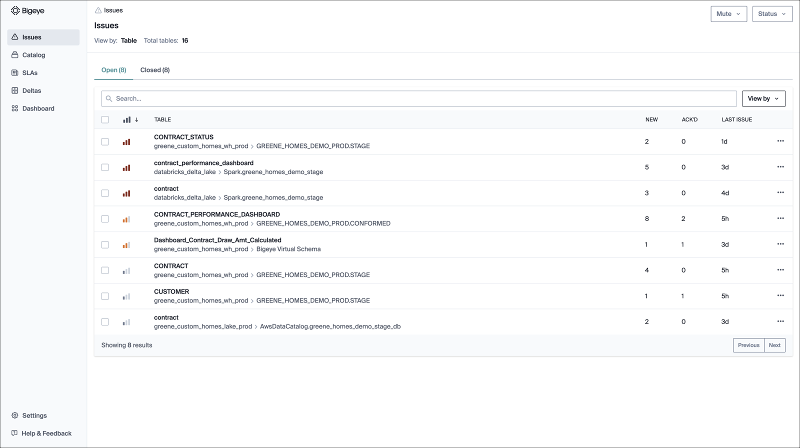

1. Issues

After you log in, the first page you land on is the **Issues** page. This page is where you can see all your data problems in a table view categorized as **Open** or **Closed**. The numbers you see next to the Open and Closed labels are their respective table counts.

Let’s learn more about the Issues interface starting with the **View by** dropdown.

**View by**

The **View by:** dropdown on the upper right-hand side has two options. The first is **View by: Table** This shows all the tables that have issues. Each row has the table name (and the schema it’s in). When you click on it, you can view the associated new issues, acknowledged issues, and the last issue reported.

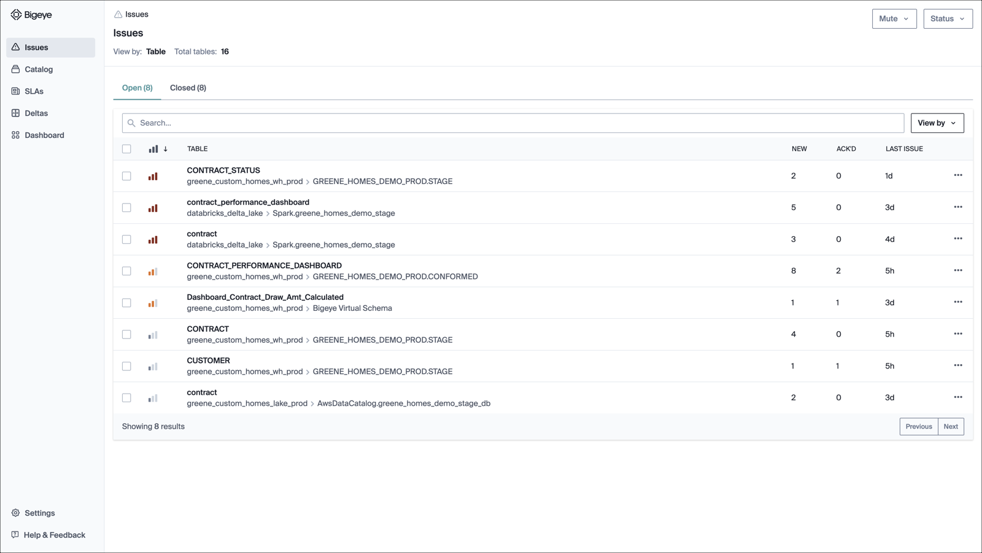

Alternatively, you can select **Issues** from the **View by** dropdown, which shows a complete list of individual issues, categorized as **Open** or **Closed** as it was in the Table view. (Note that in **View by: Issue**, the count you now see next to the Open tab and Closed tab is the issues count, and not the table count.) Each row contains issue-specific details, like the issue ID, the status, which specific metric and column the issue corresponds to, the total number of alerts sent, and the date of issue creation. You can click on the summary to go directly into the metric page.

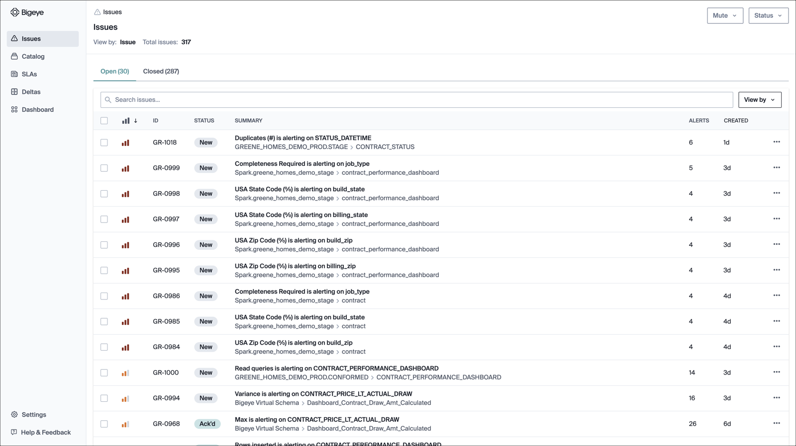

In summary, if you want to see the issues categorized schema-wise, use **Table** view. If you just want to have a quick glance at all the issues irrespective of which table they belong to, use **Issue** view.

There is much more to dive into in the Issues interface, like the priority and associated metrics of the issue, which we will cover in a separate tutorial.

Well, you now know about Issues. But what is the source of the issues, and how do you go about connecting data to monitor? Move to the **Catalog** tab.

2. Catalog

The **Catalog** tab displays a catalog of data sources that Bigeye monitors. From this initial tab, you can go deeper into each of the data sources. What does this mean?

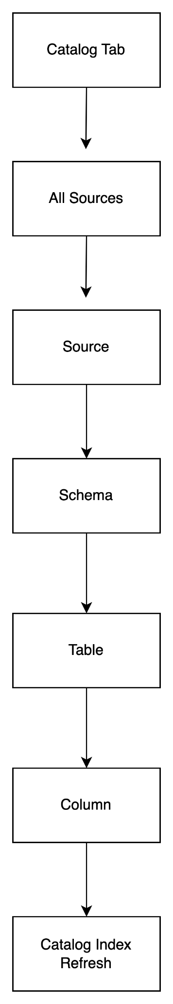

| When you click | You see | What can you do? |
| --- | --- | --- |
| Catalog tab | A catalog of sources that Bigeye monitors. | Sort the sources on any of these parameters: Schemas, Tables, Metrics, and Issues. This sorting helps understand which databases or data warehouses have the most monitoring already.  Use the **Add Source** button to add new data sources and integrations with different tools. Note: Only an admin can add a new source. |
| Sources | A listing of all of the schemas within a database or data warehouse source. | Sort the schemas by popularity, the number of tables, columns, metrics, and issues. This sorting helps understand which schemas have the most monitoring already.  Use the **Rescan Source** button to update all the metadata gathered from the source’s schemes and tables. |
| Schema | A listing of all the tables within a schema. | Sort the tables by the last refresh, popularity, row creation time, as well as the number of columns, metrics, issues, and autometrics. This sorting helps understand which tables have the most monitoring already.  Use the **Rescan Schema** button to update all the metadata gathered from the schemas’ tables. |
| Table | A listing of all the columns within a table. | Sort the columns by type, number of metrics, issues, and autometrics. This sorting helps understand which tables have the most monitoring already.  Use the **Rescan Table** button to update all the metadata gathered from all of the schemas’ tables. |
| Column | A listing of all the metrics deployed on a column. | Sort the metrics by name, health, and last updates.  Create new metrics on the column, as well as edit, delete, mute metrics and add a metric to an SLA. |

Now, you understand the issues and catalog. What about SLAs? Does it ring any bells for you?

3. SLAs

Bigeye's data observability platform works by monitoring metrics for database tables or columns, and alerting you if they go out of bounds. SLAs are arbitrary groupings of these metrics on which you can configure alerts. Here, you can see that there are a total of 6 SLAs out of which 1 is in alert mode.

Each SLA has a name and description along with the associated metrics and issues.

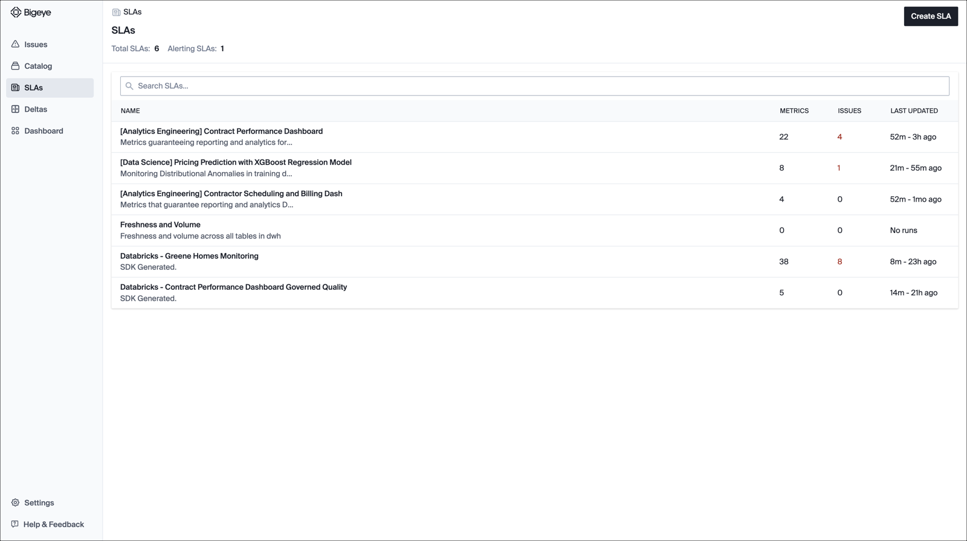

When you click an SLA name, you can view all the metrics and alerting metrics for the respective SLA. There is also an **Action** button alongside the **Search metrics** bar that gets enabled only after you select one or more metrics shown in the table. You can use the **Action** button to perform any of the following functions:

* Edit
* Refresh
* Backfill
* Mute 1 selected
* Unmute 0 selected
* Add to SLA
* Remove from SLA
* Delete

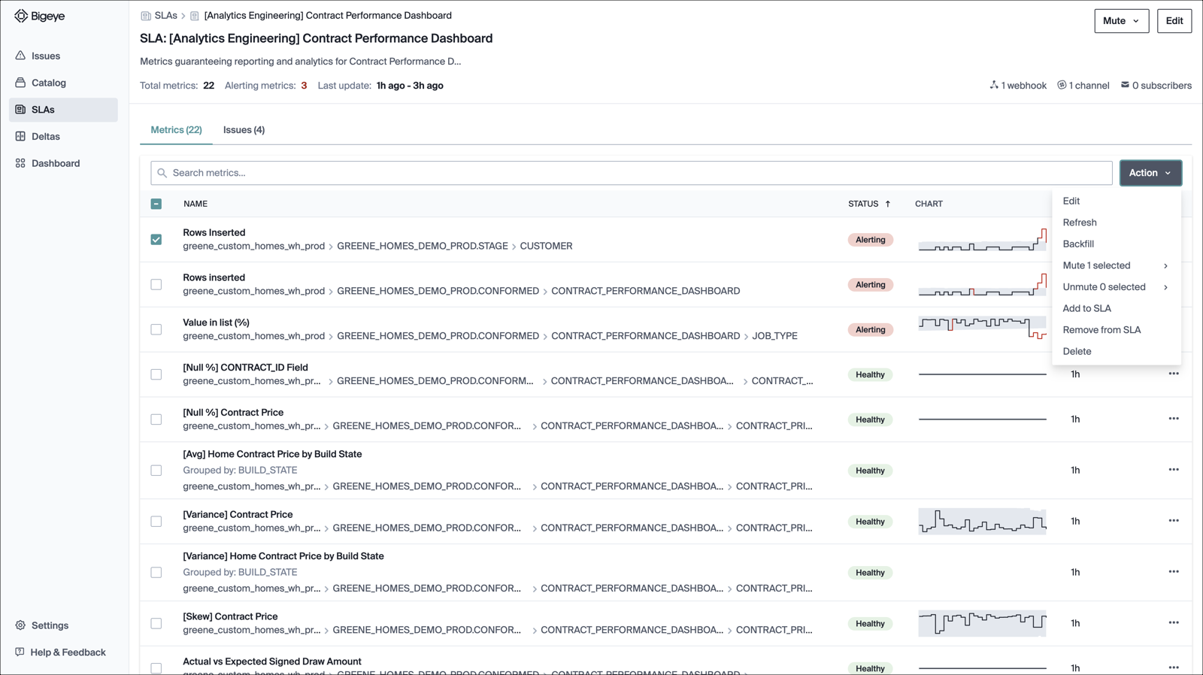

There are two other options available for each SLA metric:

**Mute** dropdown to silence the metrics for a specified period. If you already have a metric muted, you can see the Unmute option just left to the Mute button.

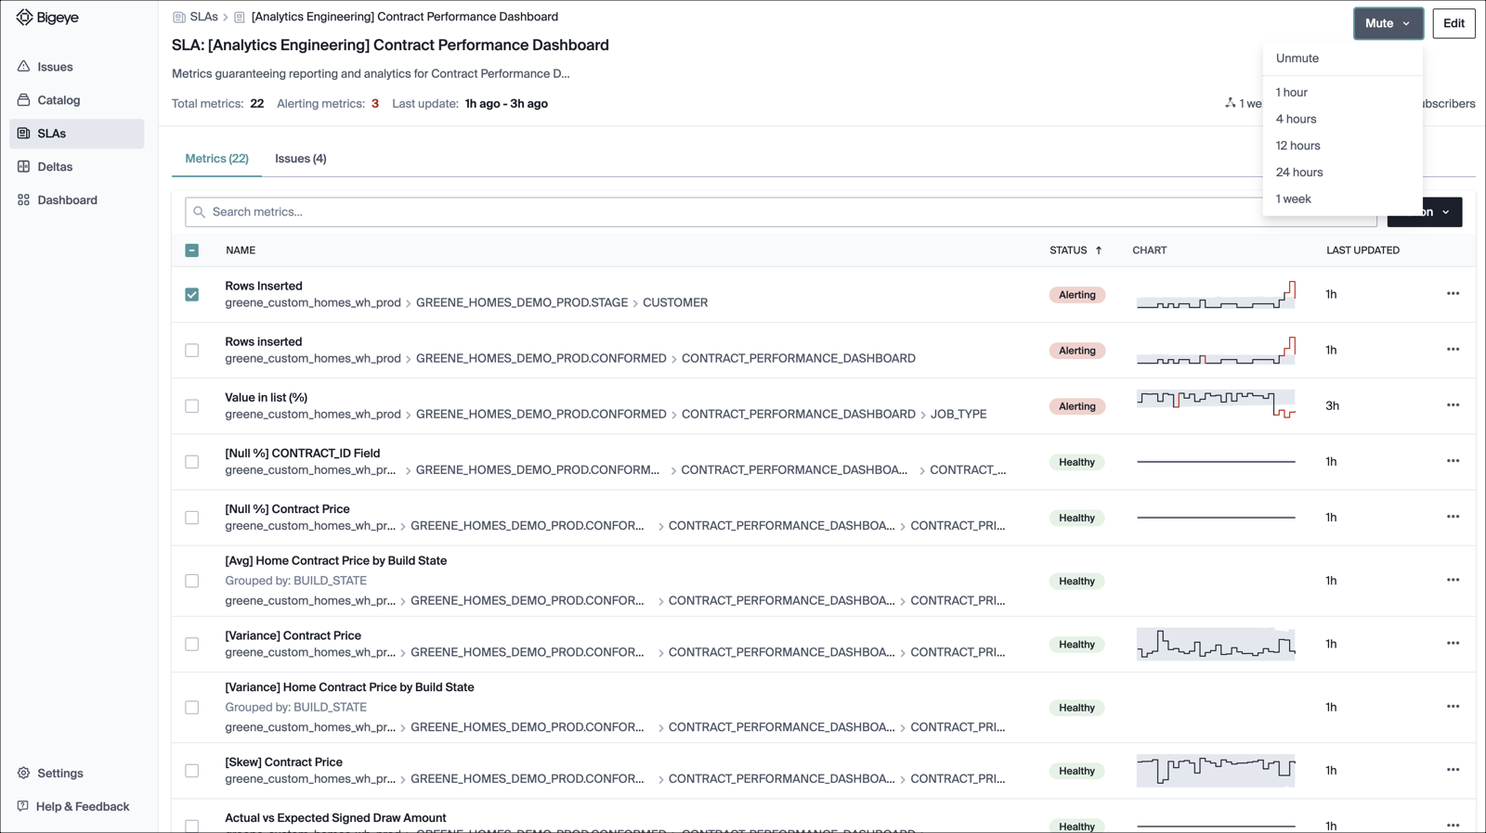

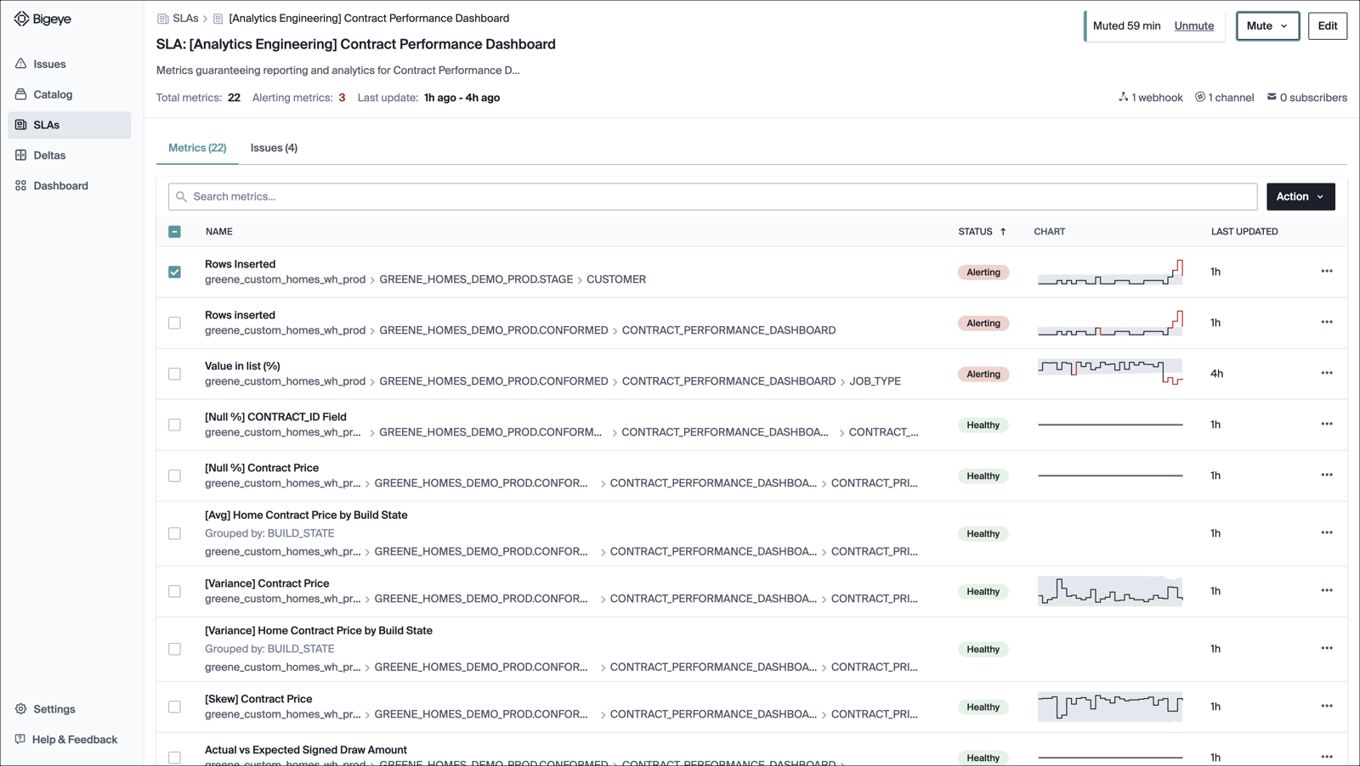

**Edit** button to make changes in the existing SLA. You can edit the SLA name, description, or how you receive notifications for the selected SLA.

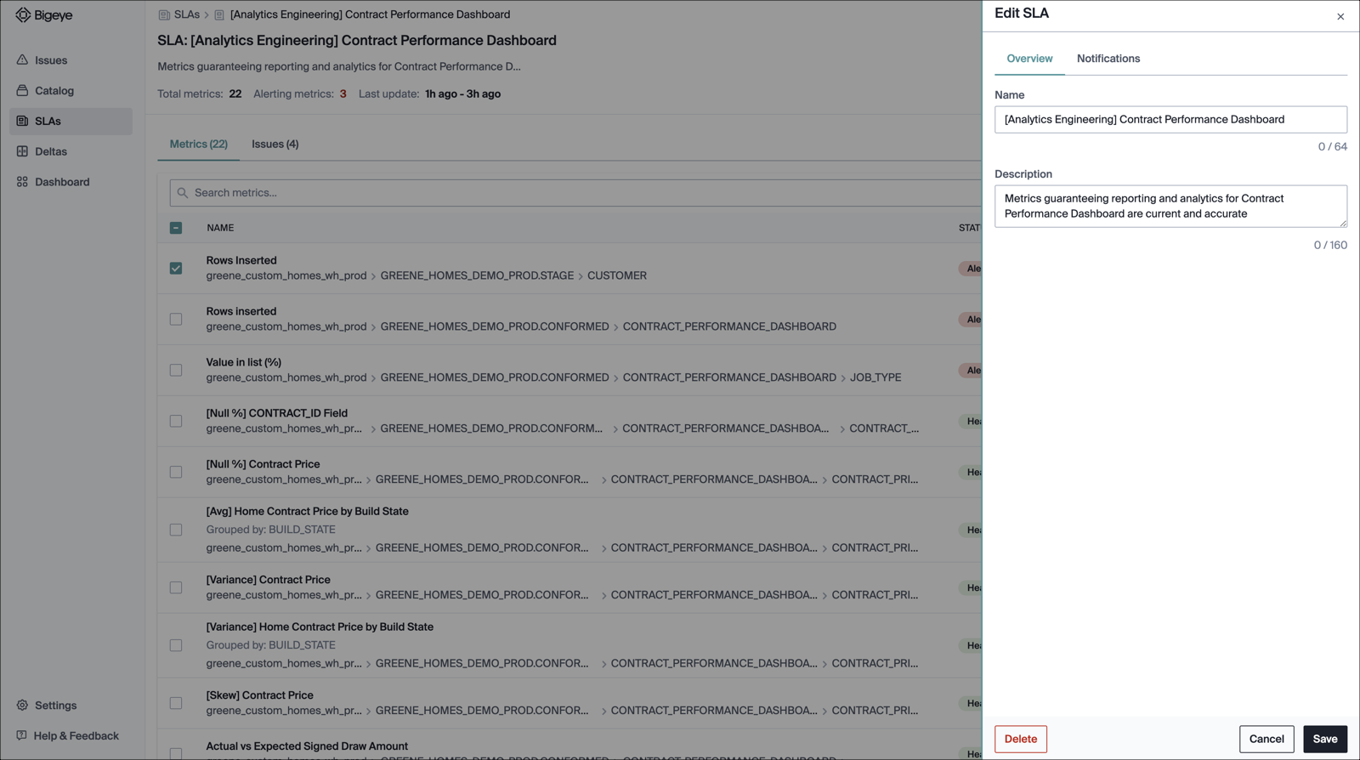

You now know what you can do with the existing SLAs. But what if you want to create a new SLA? It’s simple. Click **Create SLA** button on the SLAs overview interface to open the **Create SLA** modal, where you can enter the name and description of your SLA.

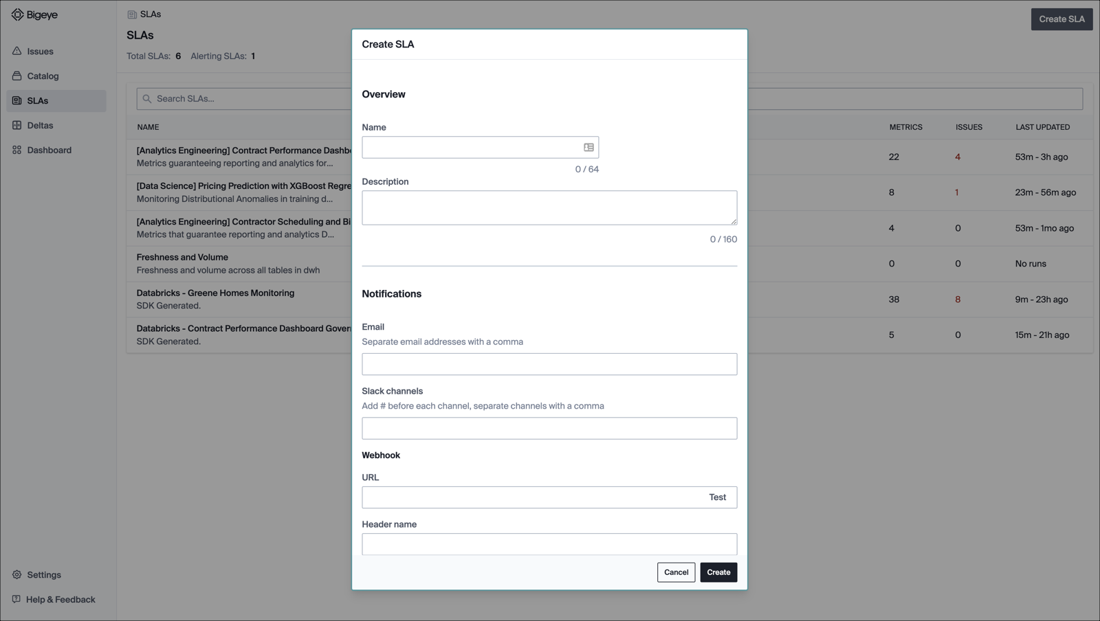

To add metrics to the SLA, go to the individual **Metrics** pages. To do this, click the **Catalog** tab, then the relevant schema/table, and then the metrics tab.

4. Deltas

If you are looking to validate your table data after a recent replication or database migration, then you can use the Bigeye **Deltas** feature. It is a tool to compare the contents of two tables and determine if any differences exist. You can compare tables between any supported data sources. Deltas are ideal for replication, database migration, and development to production use cases.

When you click the **Deltas** tab, you can see a table of existing deltas with the name, the number of metrics alerting or passing, and the last run time.

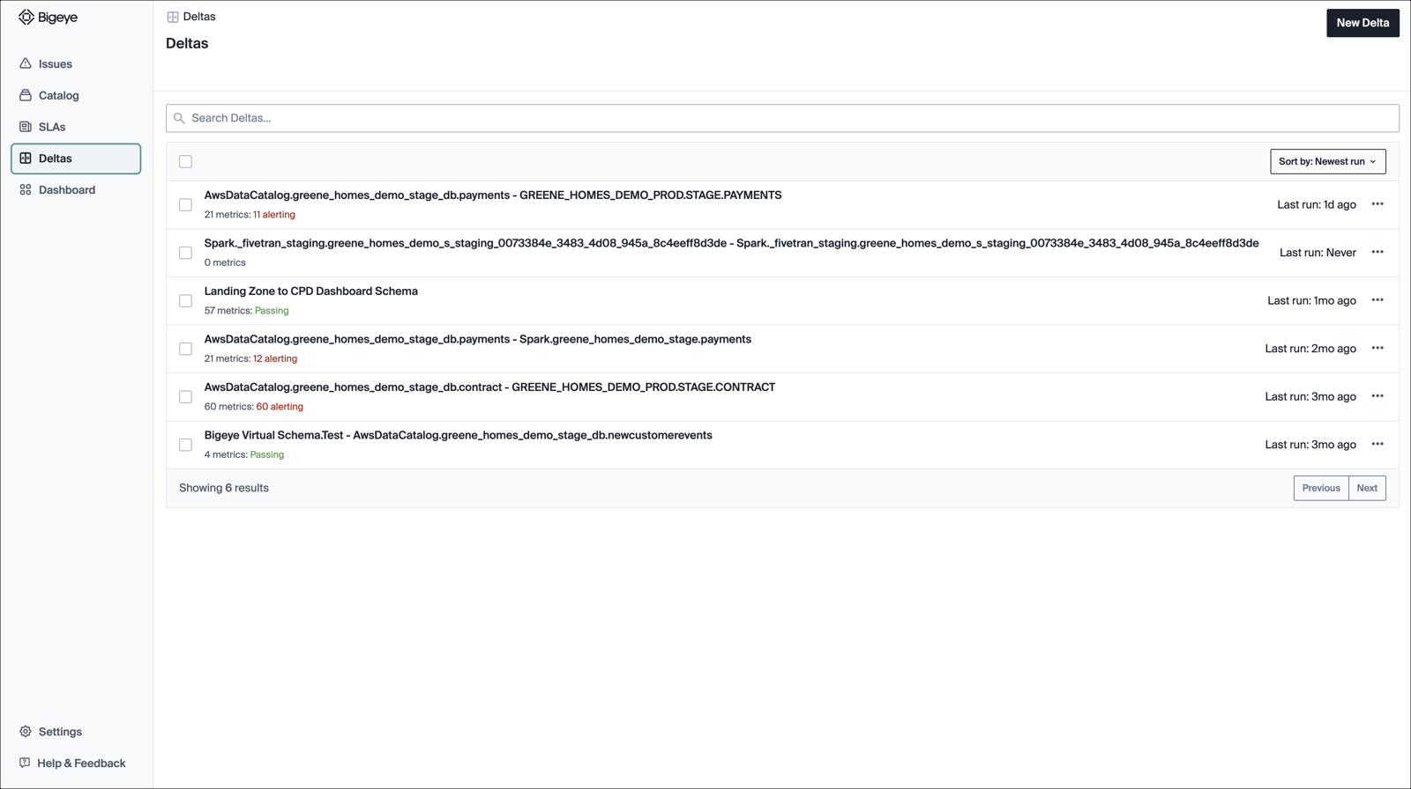

You have the option to sort deltas by

* Newest Run
* Oldest Run
* Delta Name (A-Z)
* Delta Name (Z-A)

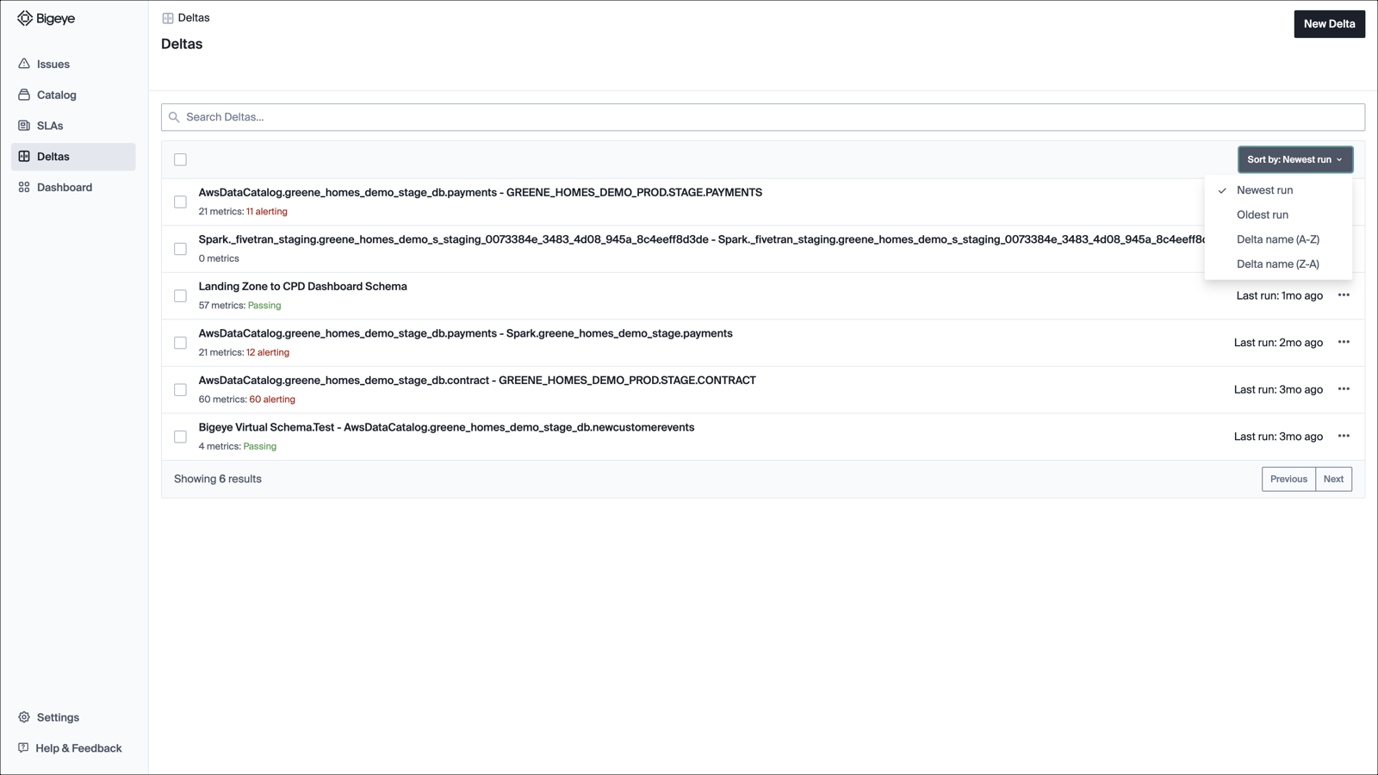

To perform a delta run or delete a delta, select one or more delta names. Once you make your selection, you will notice that the **Sort By** dropdown is replaced with three action buttons: **Run**, **Edit Schedule**, and **Delete**.

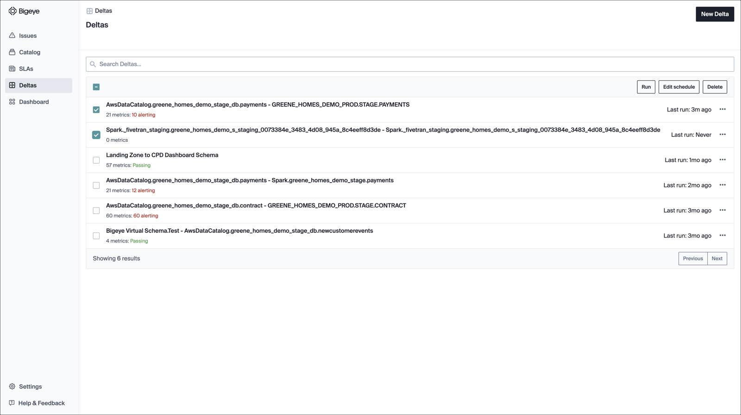

If you click on the name of a Delta, you see the details of the most recent run. The header shows the results of the run such as

* Alerts for the column pairs where the metrics don’t match
* Failed counts for the column pairs with an error
* The % match of row count from each table
* When was the last time Delta was executed

You can use the **Run** button to refresh the data or the **Edit** button to make changes to the existing delta.

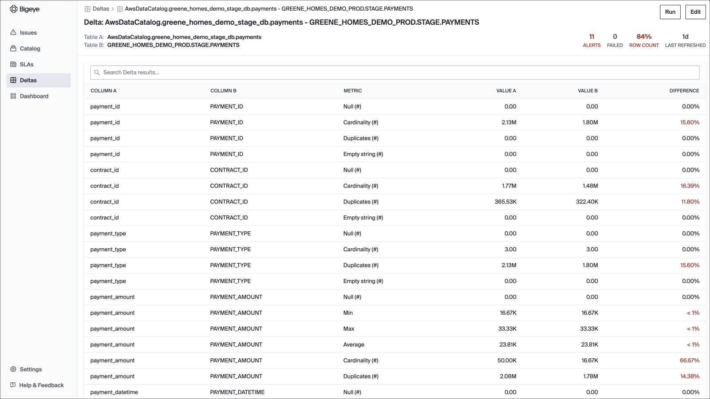

To create a new Delta, click the **New Delta** button. This will open up a modal. You can select two tables from any two data sources. Bigeye will automatically attempt to map matching columns between the two tables. You can also only check for differences in subsets or derivatives of the tables by using the **Filters** and **Group By** functionalities.

5. Dashboard

Here is where all the components of the Bigeye interface come together to show the results.

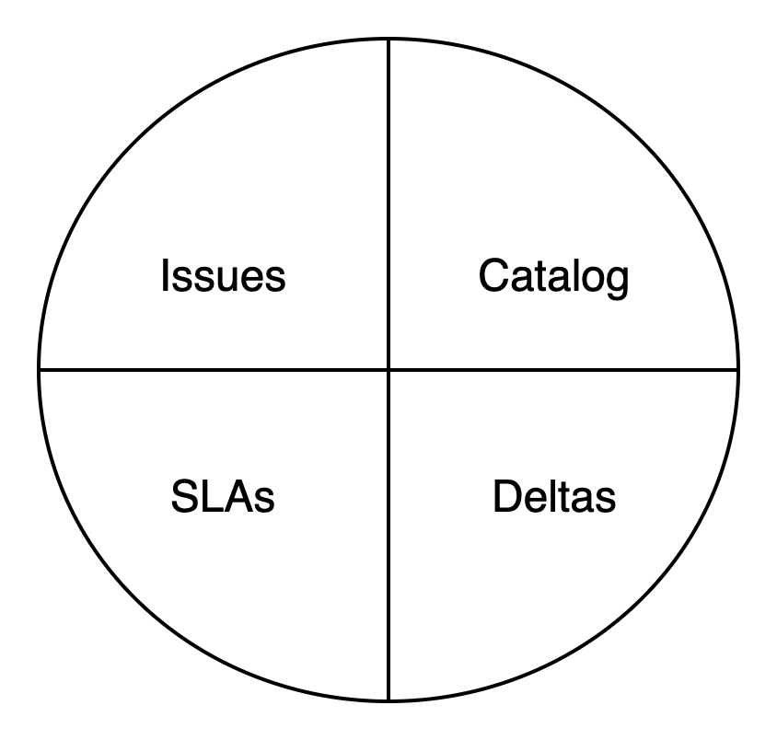

You can view a summary of the SLAs and open issues for each SLA. This is an easy way to click an SLA name and get the associated details.

There is also a **Catalog** summary showing the number of connected data sources being monitored. You can quickly check the schemas with open issues. Also, you have the option to know the number of issues Bigeye helped you resolve in the last month.

